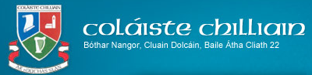

**Nuachtlitir na Samhna2020**



Fáilte chuig ár Nuachtlitir a choimeádfaidh sibh ar an eolas faoi cad atá ar siúl sa scoil, idir athraithe *agus forbairt.*

*Welcome to our newsletter which we hope will keep you updated on events in school and inform you of changes and developments in Coláiste Chilliain.*

**Ardteist / Leaving Cert 2020**

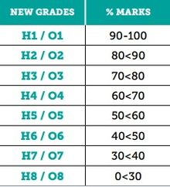

Gabhaimid comhgáirdeachas ó chroí le daltaí na séu bliana seo a chuaigh thart as ucht na torthaí iontacha a bhaineadar amach i gcoinniollacha iontach deacair. Táimid agus bhur gclann thar a bheith bróduil asaibh. Tréaslaimid le beirt dalta ach go háirithe – iad siúd a bhuaigh scoláireachtaí Chairde Chilliain.

Scothscoláire: Seosamh Ó Muirí

*Pointí is Airde: Ben Inglis (613)*

*We would like to extend our heartiest congratulations to our outgoing 6th years who did themselves, their families and the school proud in especially difficult circumstances, with their fine results. We would especially like to commend our two Cairde Chilliain scholarship winners.*

*Scoth Scoláire (Student of the Year) – Seosamh Ó Muirí*

*Highest points achieved (613) – Ben Inglis*

**Foireann / Staff**



Ba mhaith linn fáilte Uí Cheallaigh a chur roimh na múinteoirí nua atá linn sa scoil bhliain nua seo.

Tá triúr múinteoir ar sos-máithreachais agus múinteoir eile ar sos-gairme. Guímid gach rath orthu.

Is le croí trom a d’fhágamar slán le Pól Ó Sluagháin a ceapadh mar Phríomhoide ar Ballydowd Special school mí Meán Fómhair seo caite.

*I would like to welcome our new staff members who have joined us this academic year. They are:*

*Aoife Ní Shúilleabháin – Fraincis, Gaeilge & Spórt*

*Shauna Ní Choileáin – Béarla & Feabhas/Learning Support*

*Tristan Bailey – Béarla & Reiligiún*

*Séamus Ó Raghallaigh – Gaeilge & Stair*

*We have three teachers on Maternity leave and one on Career Break – We wish them all the best.*

*We also bid farewell to Pól Ó Sluagháin (Béarla & Reiligiún) who was appointed as principal in Ballydowd Special School in September. Adh mór sa phost nua.*

**Amchlár Nua / New Timetable**

Mar a mhíníodh sa Phlean Athoscailt Scoile táimid bogtha go dtí tréimhsí uair a chloig anois. Táimid uilig, idir mhúinteoirí agus daltaí ag dul i dtaithí air ach tá an aischothú dearfach ar an iomlán. Tá níos lú bogadh timpeall na scoile agus níos lú leabhair le hiompar de bharr 6 thréimhse in ionad naoi a bheith i gceist.

*As outlined in our school reopening plan we have moved to hour long periods. We all, teachers and pupils are getting used to the new timetable but feedback seems to be positive. There is less movement during the school day and fewer books are needed due to there being 6 periods instead of 9.*

**Covid-19**

Mar is eol daoibh níor tháinig an scoil slán ón bpaindéim ó d’osclaíomar. Buaileadh bliain 6 go dona ag tús Meán Fómhair agus bhí orthu aonrú sa bhaile de réir treoracha an FSS. Tharla teagasc ar líne ach cinnte bhí roinnt fadhbanna.

Ansin ag deireadh Meán Fómhair thástáil ball foirne dearfach agus dúirt an FSS le seisear ball foirne eile aonrú a dhéanamh bunaithe ar eolas a tháinig ón aip a thug le fios gur teagmháil cóngarach a bhí iontu uilig. Buíochas le Dia bhíodar go léir diúltach.

Ba mhaith liom an deis seo a thapú buíochas a ghabháil le daltaí agus tuismitheoirí as ucht a dtuiscint agus foighne i rith an ama seo. Bhí orainn iarraidh ar bhlianghrúpaí éagsúla fanacht sa bhaile (seachas bliain 6) ar leathanta difriúla ionas go bhféadfaimis an scoil a choimeád ar oscailt. Is cinneadh deacair a bhí ann ach d’oibrigh sé. D’fhan an scoil ar oscailt agus tugadh obair dos na ranganna a bhí ar scoil agus freisin ar Google Classroom dóibh siúd sa bhaile.

Má tá fadhb le hobair ar líne bheinn buíoch dá gcuirfeadh sibh an scoil ar an eolas ionas gur féidir linn gníomhú ar an bhfadhb.

*As you are well aware the school has not escaped the effects of the pandemic. Our sixth year cohort were hit in September and the whole year were directed by the HSE to self-isolate. On-line teaching occurred successfully but with some hitches.*

*Then at the end of September a member of staff tested positive and the HSE, following the registering of Covid-19 app tracking system identified 6 teachers as close contacts who were then obliged to self-isolate for 14 days. Thankfully they all had negative results.*

*I would like to take this opportunity to thank both pupils and parents for their patience and understanding during this period. It was necessary to ask various year groups (6th year excluded) to work from home on different days to facilitate the school staying open. It was a difficult decision but one that worked. The school stayed open and work was assigned to the classes attending and also on Google Classroom for those working from home.*

*We are always glad of communication on these matters. If there is a query or a difficulty please contact us so that we can attempt to rectify the situation.*

**Clúdach Aghaidhe / Masks**

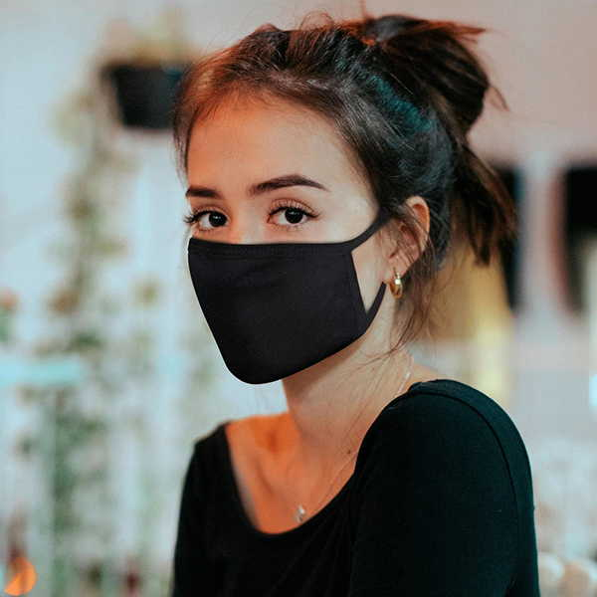

Táimid an-thógtha le cur chuige na ndaltaí i leith caitheamh na gclúdaigh aghaidhe. Níl sé éascaí orthu ach tuigeann siad an tábhacht a bhaineann leo chun an scaipeadh a stopadh. Bheimis buíoch dá gcuirfeadh sibh in iúl sa bhaile freisin an tábhacht a bhaineann leis an béal AGUS srón a bheith clúdaithe.

Áit amháin atá mar ábhar buairte dúinn ná ag am sosa/lóin. Tá sé go maith dos na daltaí dul amach faoin aer ach má bhaineann siad na clúdaigh aghaidhe chun sos uatha a ghlacadh caithfidh siad scarúint 2 mhéadar óna chéile. Mura ndéantar amhlaidh tá baol ann.

Fadhb eile ná go dtéann cairde isteach i mbunseomraí a gcairde. NÍL seo ceadaithe agus iarraim oraibh an teachtaireacht seo a chur in iúl dóibh arís.

Iarraimid oraibh an teachtaireacht na lámha a ní go minic a threisiú leo i gcónaí.

*We are very impressed with our pupils with regard to mask wearing. It has been difficult for them but they have embraced the necessity and fully support it. We would ask however that you reiterate with your children that the mask must cover both the mouth and the nose.*

*One issue we have is mask wearing at break times. We encourage all pupils to get fresh air at break times. It is also a chance for a relief from mask wearing. However, if the mask is removed pupils MUST remain at least two metres apart. Social distancing does not take a break and masks should remain on if this social distancing is not adhered to.*

*Another issue at lunchtime is pupils going into their friends’ base classrooms. This should not happen and we would ask you to repeat this message.*

*We would also ask you to emphasise the importance of hand washing with your sons/daughters.*

**Díghalrú / Wipes**

Is gá dúinn iarracht bhreise a dhéanamh maidir le glanadh na boird i ndiaidh rang mheascaithe. Tarlaíonn seo go minic i meánscoileanna – ranganna teangacha/Mata/Praiticiúla. Iarraimid ar dhaltaí na boird a ghlanadh más rud é go bhfuil siad i seomra eile. Dá bhféadfadh sibh a chinntiú go bhfuil a dhóthain dí-ghalrú acu bheadh sé ina chabhair mhór.

*One area where our hygiene regime needs to be tightened is when groups are mixed. This is inevitable in secondary schools where maths, languages, choice subject classes are necessarily mixed. We ask pupils to wipe the table if they are in a room that is not their base room. In order to do this, I ask you to make sure your child has a steady supply of wipes.*

**Foirm Iarratais / Application Forms – 2021/22 School Year**

**

Tá córas nua clárú do mheánscoileanna in Éirinn anois. Ní féidir clárú d’aon mheánscoil go dtí tar éis an 1ú Dheireadh Fómhair i rang a sé. Tá na foirmeacha ar fáil ar ár suíomh, [www.colaistechilliain.ie](http://www.colaistechilliain.ie) faoi ‘Eile’ agus ‘Doiciméid’. Is é an spriocdáta don scoilbhliain 2021/22 ná an 23ú Deireadh Fómhair 2020 agus is iarratais dhéanacha iad aon foirm a thagann tar éis an dáta sin.

*There is a new procedure for all secondary school in Ireland regarding enrolment. The new application forms are available on our website,* [*www.colaistechilliain.ie*](http://www.colaistechilliain.ie) *under ‘Other’ and ‘Documents’. The new rules state that applications for the next academic year can only be accepted after October 1st of the previous year. The closing date for applications for Coláiste Chilliain for the 2021/2022 school year is October 23rd,2020. All forms received after that date will be considered late applications.*

**Cruinnithe Tuismitheoirí Múinteoirí / Parent Teacher meetings.**



Go dtí seo níl aon treoir tagtha ón Roinn Oideachais maidir leis na cruinnithe seo. Is léir áfach nach mbeidh tuismitheoirí ag bualadh isteach chugainn. Tá blianta 1,2,3,5 & 6 ag déanamh Measúnú 1 faoi láthair agus beidh na torthaí le feiceáil ar VS Ware faoin sos lár-théarma. Beimid i dteagmháil leis na tuismitheoirí bealach amháin nó bealach eile chun dul chun cinn a bpáistí a phlé. Coimeádfar ar an eoals sibh.

*As yet no directions have been issued from the Department of Education regarding Parent-Teacher Meetings. It goes without saying however that we will not be having face to face meetings. The pupils in 1st,2nd, 3rd 5th and 6th year are undergoing assessments at the moment and the results will be available on VS Ware by the mid-term break. We will be contacting the parents of the relevant year groups to discuss progress in some form or other. We will keep you informed.*

**Costais / Costs**



Tá táillí scoile íoctha ag an-chuid tuistí agus táimid buíoch as sin. Tá sé tábhachtach go n-íocfar ar líne mar níl cead airgead tirim a thógáil.

Beimid ag eagrú aisíocaíochtaí dóibh siúd a d’íoc as rudaí nach bhfuil ar fáil i mbliana. (Taisceadáin mar shampla).

*Many of you have paid school costs on line and we are very grateful for that. It is more important now than ever that payments are made online as we cannot accept money in any other form.*

*We will be organising a refund for those who have paid for items that are no longer available or are not being used (lockers for example).*

**Idirbhliain / Transition Year**

Tá costais na hidirbhliana á laghdú againn i mbliana chuig €150. Níl an méid céanna busanna á ordú (atá fíor-chostasach) ach tá aoi-chainteoirí agus ceárdlainn á eagrú atá costasach freisin. Is minic a bhí na turais soar n-aisce agus bhain an costas leis an iompar.

Tá tionscnamh mór á dhéanamh ag daltaí na hIdirbhliana chun seomra ranga/fóillíochta lasmuigh a chruthú lasmuigh de seomraí 12/13/Bith/Ceim. Táimid ag lorg pailéid a bheidh mar bhunús na suíocháin agus aon saineolais ar tógáil díon.

*Transition Year costs are being reduced from €250 to €150. While we are not ordering as many buses we are bringing in guests and organising workshops. These are expensive and require funding. Many of the usual TY trips were often to free venues. The bus cost was the major issue.*

*There is a major TY project underway to create an outdoor classroom/recreation area outside rooms 12/13 and Biology/Chemistry. We are appealing to all for pallets which would be the base for the seating area envisaged. Any gardening tools or roof construction expertise would be gratefully received.*

**Bliain 1 / 1st Year**

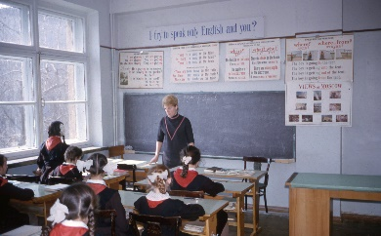

Cuirimid fáilte is fiche roimh an 63 dalta sa chéad bhliain. Tá an cuma orthu go bhfuil siad ag socrú síos go maith in aineoinn na coinníollacha aimscí. Tá an fhoireann an-thógtha leis an mbealach aibí agus tuiscineach atá acu. Ba chóir go mbeadh a gclann bródúil astu.

Beimid ag seoladh eolais maidir le VS Ware agus Rogha Ábhair nuair atá an tréimhse blaiseadh thart.

*We extend a heartfelt and warm welcome to our 63 first years. They seem to be settling in very well despite the difficult circumstances and all staff are taken with their understanding and maturity. They are doing their families proud. We will be issuing 1st year parents with information to access VS Ware and we will be informing them of the system for choosing their subjects after the taster period is completed.*

**Teagasc & Foghlaim ar líne / On-Line Teaching & Learning**



I gcás go n-iarrann an FSS nó an Rialtas ar an scoil dúnadh (cé nach bhfuil dúnadh scoile fiú luaite ag céim 5) is é an plean ná amchlár na scoile a leanúint le meascán idir ranganna beo agus obair ar líne, go léir tré Google Classroom. Ní mholaimid ranganna beo i gcónaí mar measaimid nach bhfuil sé sláintiúil don dalta nó don mhúinteoir. Tuigtear áfach gur ranganna beo a bheidh mar thromlach na ranganna.

Iarraimid oraibh teagmháil a dhéanamh leis an scoil má tá deacracht teacht ar an obair nó ranganna beo. Déanfaimid ár ndícheall an fhadhb a réiteach gan mhoill.

*In the case of a schools being told to close by the HSE or the Government (though this is not envisaged even at level 5) our plan is to follow the existing timetable with a mixture of live classes and assigned work on Google Classroom. We believe a mixture rather than constant live classes is healthier for both pupils and teachers. We would, however envisage more live classes than not.*

*We would ask you to contact the school if there is a difficulty with accessing work/live classes. We will try to resolve the issue in a timely manner.*